**Homework 3**

**Arjun lakshmikanth (1001192326)**

1. **First Question**

Connect through SSH

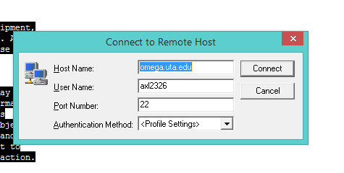

Login to Stampede

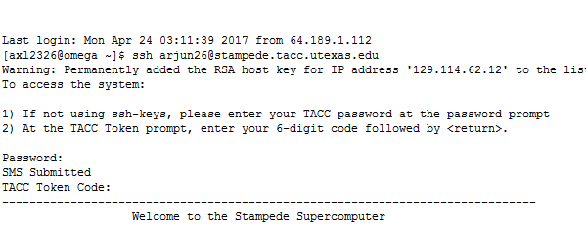

Login to Compute node using the following command.

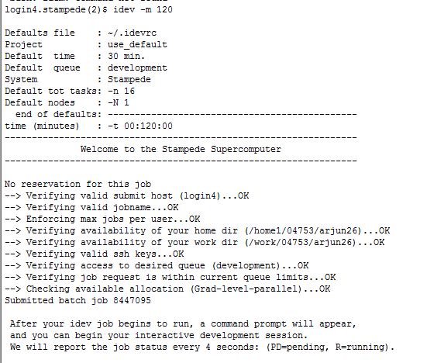

Code:

#include <stdio.h>

#include <math.h>

#include "mpi.h"

int main(argumentc, argumentv)

int argumentc;

char **argumentv;

{

MPI_Init(&argumentc, &argumentv);

int rankc;

int sizec;

float tvalue = 0;

float lowboundry;

float upboundry=0;

int i=0;

float mul = 0;

int gap=0;

float pi=0;

float sumofpi=0;

float answer = 0;

float exactpi = 3.14159265358;

MPI_Status status;

float total;

MPI_Comm_rank(MPI_COMM_WORLD, &rankc);

MPI_Comm_size(MPI_COMM_WORLD, &sizec);

if(rankc !=0)

{

MPI_Recv(&gap, 1, MPI_INT, 0, rankc, MPI_COMM_WORLD, &status);

for(i=rankc; i<gap; i=(i-1)+sizec)

{

tvalue = ((float)i/gap);

pi = ((float)4/(1+(tvalue*tvalue)));

if(i%2!=0)

{

pi = pi*4;

}

else

{

pi = pi*2;

}

sumofpi = sumofpi + pi;

}

MPI_Send(&sumofpi,1,MPI_FLOAT,0,rankc,MPI_COMM_WORLD);

}

else if(rankc==0)

{

printf("\nNumber of gaps(>400000): ");

scanf("%d", &gap);

lowboundry=((float)4/(1+0));

upboundry=((float)4/(1+1));

float temp_pi_res[gap];

for(i=1; i<sizec; i++)

{

MPI_Send(&gap,1,MPI_INT,i,i,MPI_COMM_WORLD);

MPI_Recv(&temp_pi_res[i], 1, MPI_FLOAT, i, i, MPI_COMM_WORLD, &status);

answer = answer+temp_pi_res[i];

}

total = lowboundry + upboundry;

answer = answer+total;

mul = (3*gap);

answer = answer/mul;

printf("\nPI value=% .16f\n Error is % .16f\n", answer, fabs(answer - exactpi));

}

MPI_Finalize();

return 0;

}

Compiling and Running the code:

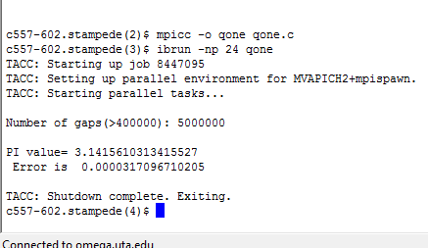

1. **Second Question**

Code:

#include <stdio.h>

#include "mpi.h"

int sizeval=0;

int values=0;

void Arrayshift(int original_array[], int new_array[],int factorforshift, int shift_portion[] );

void Right(int original_array[], int new_array[], int factorforshift, int shift_portion[]);

void Left(int original_array[], int new_array[], int factorforshift, int shift_portion[]);

int main( int cvalue, char *valuev[] )

{

int factorforshift;

int new_position;

int element;

int i= 0;

int procrank;

int sizeval;

MPvaluestatus status ;

MPI_Init(&cvalue, &valuev);

MPI_Comm_rank(MPI_COMM_WORLD, &procrank);

MPI_Comm_size(MPI_COMM_WORLD, &sizeval);

if ( (sizeval == 2) || (sizeval == 4) || (sizeval == 8) || (sizeval == 16))

{

}

else

{

MPI_Abort(MPI_COMM_WORLD, i);

exit(0);

}

if(procrank == 0)

{

printf("Input Array Size:\n");

scanf("%d", &values);

printf("\nShift factor ");

scanf("%d", &factorforshift);

int input_array[values];

int new_array[values];

int shift_portion[values];

printf("Enter processor rank: %d\n", procrank);

for(i = 0; i < values; i++)

{

printf("\nA[%d]:",i);

scanf("%d", &input_array[i]);

}

if(factorforshift < 0)

{

while(factorforshift < (-values))

{

factorforshift = factorforshift + values;

}

}

else if(factorforshift > 0)

{

while(factorforshift > values)

{

factorforshift = factorforshift - values;

}

}

if(sizeval > 1)

{

for (element = 1; element < sizeval; element++)

{

MPvaluesend(&factorforshift, 1, MPI_INT, element, element, MPI_COMM_WORLD);

MPvaluesend(&values, 1, MPI_INT, element, element, MPI_COMM_WORLD);

printf("Enter pricessor rank : %d\n", element);

for(i = 0; i < values; i++)

{

printf("\nA[%d]:",i);

scanf("%d", &new_array[i]);

}

MPvaluesend(&new_array, values, MPI_INT, element, element, MPI_COMM_WORLD);

}

}

shiftArray(input_array, new_array, factorforshift,shift_portion );

if(factorforshift < 0)

{

new_position = (-factorforshift );

}

else

{

new_position = factorforshift;

}

if(sizeval > 1)

{

if(factorforshift >= 0)

{

MPvaluesend(&shift_portion, new_position, MPI_INT, 1, 1, MPI_COMM_WORLD);

MPI_Recv(&shift_portion, new_position, MPI_INT, (sizeval - 1), (sizeval - 1), MPI_COMM_WORLD, &status);

}

else

{

MPvaluesend(&shift_portion, new_position, MPI_INT, (sizeval - 1), (sizeval - 1), MPI_COMM_WORLD);

MPI_Recv(&shift_portion, new_position, MPI_INT, 1, procrank, MPI_COMM_WORLD, &status);

}

}

if(factorforshift >= 0)

{

for(i = 0; i < factorforshift; i++)

{

new_array[i] = shift_portion[i];

}

}

if(factorforshift < 0)

{

for(i = 0, element = (values + factorforshift); element < values; i++, element++)

{

new_array[element] = shift_portion[i];

}

}

for(i = 0; i < values; i++)

{

printf("Original Array : %d, New Array is : %d \n",input_array[i], new_array[i]);

}

if(sizeval > 1)

{

for (element = 1; element < sizeval; element++)

{

MPvaluesend(&factorforshift, 1, MPI_INT, element, element, MPI_COMM_WORLD);

MPI_Recv(&factorforshift, 1, MPI_INT, element, procrank, MPI_COMM_WORLD, &status);

}

}

}

else if (procrank !=0)

{

MPI_Recv(&factorforshift, 1, MPI_INT, 0, procrank, MPI_COMM_WORLD, &status);

MPI_Recv(&values, 1, MPI_INT, 0, procrank, MPI_COMM_WORLD, &status);

int input_array[values];

int new_array[values];

int shift_portion[values];

int inter_array[values];

if(factorforshift < 0)

{

new_position = factorforshift * -1;

}

else

{

new_position = factorforshift;

}

MPI_Recv(&input_array, values, MPI_INT, 0, procrank, MPI_COMM_WORLD, &status);

shiftArray(input_array, new_array, factorforshift,shift_portion);

if(factorforshift >= 0)

{

MPI_Recv(&inter_array, new_position, MPI_INT, (procrank - 1), procrank, MPI_COMM_WORLD, &status);

for(i = 0; i < factorforshift; i++)

{

new_array[i] = inter_array[i];

}

}

if(factorforshift < 0)

{

if(procrank == (sizeval - 1))

{

MPI_Recv(&inter_array, new_position, MPI_INT, 0, procrank, MPI_COMM_WORLD, &status);

}

else

{

MPI_Recv(&inter_array, new_position, MPI_INT, (procrank + 1), procrank, MPI_COMM_WORLD, &status);

}

for(i = 0, element = (values + factorforshift); element < values; i++, element++)

{

new_array[element] = inter_array[i];

}

}

if(procrank == (sizeval - 1))

{

if(factorforshift >= 0)

{

MPvaluesend(&shift_portion, new_position, MPI_INT, 0, procrank, MPI_COMM_WORLD);

}

else

{

MPvaluesend(&shift_portion, new_position, MPI_INT, (procrank - 1), (procrank - 1), MPI_COMM_WORLD);

}

}

else

{

if(factorforshift >= 0)

{

MPvaluesend(&shift_portion, new_position, MPI_INT, (procrank + 1), (procrank + 1), MPI_COMM_WORLD);

}

else

{

MPvaluesend(&shift_portion, new_position, MPI_INT, (procrank - 1), (procrank - 1), MPI_COMM_WORLD);

}

}

MPI_Recv(&factorforshift, 1, MPI_INT, 0, procrank, MPI_COMM_WORLD, &status);

for(i = 0; i < values; i++)

{

printf("Input array: %d, Array shift : %d \n",input_array[i], new_array[i]);

}

MPvaluesend(&factorforshift, 1, MPI_INT, 0, 0, MPI_COMM_WORLD);

}

MPI_Finalize();

return 0;

}

void shiftArray(int original_array[], int new_array[], int factorforshift, int shift_portion[])

{

int inter_array[values];

if(factorforshift >= 0)

{

Right(original_array, new_array, factorforshift, shift_portion);

}

if(factorforshift < 0)

{

Left(original_array, new_array, factorforshift, shift_portion);

}

}

void Right(int original_array[], int new_array[], int factorforshift, int shift_portion[])

{

int i = 0, j = 0;

for(j = 0; j <= factorforshift; j++)

{

new_array[j] = original_array[i];

}

for(i = 1; i < ( values - factorforshift); i++, j++)

{

new_array[j] = original_array[i];

}

for(i = 1; i <= factorforshift; i++)

{

shift_portion[i-1] = original_array[values - factorforshift + i - 1];

}

}

void Left(int original_array[], int new_array[], int factorforshift, int shift_portion[])

{

int i = 0, j = 0;

i = -1;

for(j = 0; j <= (values + factorforshift); j++)

{

new_array[j] = original_array[(factorforshift * i) + j];

}

for(j = 0; j <= (factorforshift * i); j++)

{

shift_portion[j] = original_array[j];

}

}

Code compilation and output:

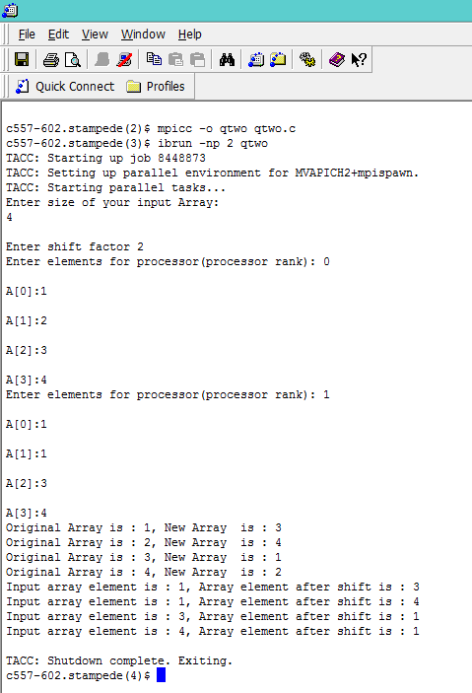

1. **Question three**

**MPI_scatter CODE**

#include <mpi.h>

#include <stdio.h>

#include <stdlib.h>

int main(int argc, char **argv) {

int size, rank;

MPI_Init(&argc, &argv);

MPI_Comm_size(MPI_COMM_WORLD, &size);

MPI_Comm_rank(MPI_COMM_WORLD, &rank);

int *globaldata=NULL;

int localdata;

if (rank == 0) {

globaldata = malloc(size * sizeof(int) );

for (int i=0; i<size; i++)

globaldata[i] = 2*i+1;

printf("Processor %d has data: ", rank);

for (int i=0; i<size; i++)

printf("%d ", globaldata[i]);

printf("\n");

}

MPI_Scatter(globaldata, 1, MPI_INT, &localdata, 1, MPI_INT, 0, MPI_COMM_WORLD);

printf("Processor %d has data %d\n", rank, localdata);

localdata *= 2;

printf("Processor %d doubling the data, now has %d\n", rank, localdata);

MPI_Gather(&localdata, 1, MPI_INT, globaldata, 1, MPI_INT, 0, MPI_COMM_WORLD);

if (rank == 0) {

printf("Processor %d has data: ", rank);

for (int i=0; i<size; i++)

printf("%d ", globaldata[i]);

printf("\n");

}

if (rank == 0)

free(globaldata);

MPI_Finalize();

return 0;

}

**MPI_Gather Code:**

#include <mpi.h>

#include <stdio.h>

#include <stdlib.h>

int main(int cvalue, char **vvalue)

{

int size, rank;

MPI_Init(&cvalue, &vvalue);

MPI_Comm_size(MPI_COMM_WORLD, &size);

struct timeval tvBegin,tvEnd,tvDiff;

MPI_Comm_rank(MPI_COMM_WORLD, &rank);

int *globalvar=NULL;

int localvar;

if (rank == 0) {

globalvar = malloc(size * sizeof(int) );

for (int i=0; i<size; i++)

globalvar[i] = 2*i+1;

gettimeofday(&tvBegin,NULL);

printf("%d data on Processor : ", rank);

for (int i=0; i<size; i++)

printf("%d ", globalvar[i]);

printf("\n");

}

MPI_Send(globalvar, 1, MPI_INT, &localvar, 1, MPI_INT, 0, MPI_COMM_WORLD);

printf("Processor %d has data %d\n", rank, localvar);

MPI_Gather(&localvar, 1, MPI_INT, globalvar, 1, MPI_INT, 0, MPI_COMM_WORLD);

gettimeofday(&tvEnd,NULL);

if(rank==0){

printf("The Point-to-point communication time is %f\n",(float)( (tvEnd.tv_usec-tvBegin.tv_usec)/100));

}

if (rank == 0)

{

printf("Processor %d has data: ", rank);

for (int i=0; i<size; i++)

printf("%d ", globalvar[i]);

printf("\n");

}

if (rank == 0)

free(globalvar);

MPI_Finalize();

return 0;

}

MPI Scatter data plotted:

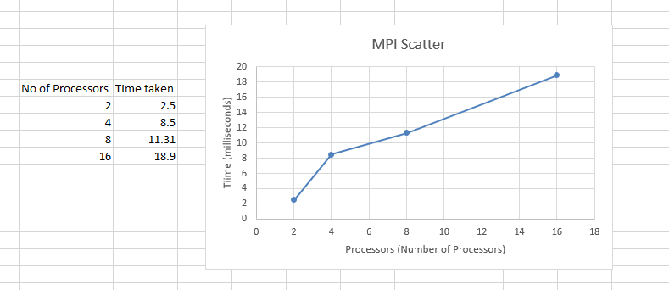

MPI Gather data plotted:

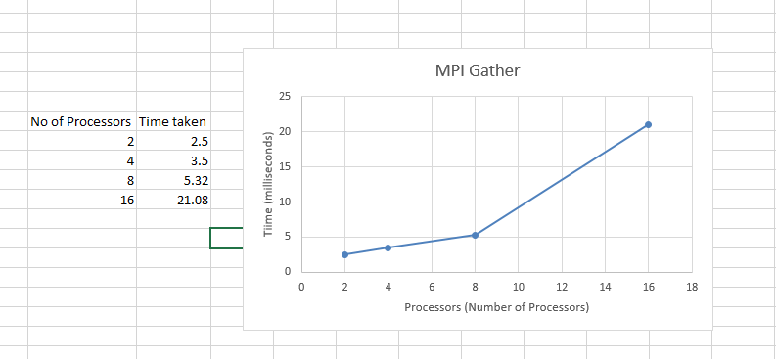

----------------- End of Document--------------------